Secretary Record Book Information
The Secretary's Record Book is basically a Club Record Book. Essentially, it is the summary of members, leaders, activities, attendance, financial reports, accomplishments, and an overall narrative of these accomplishments each year.
One of the most important things to realize is that this particular record is not the sole responsibility of the club secretary. It is shared by these people: the club secretary, treasurer, reporter, and the general and assistant adult leaders who work with the club officers to identify needs, leadership, and programs for the club or who at least gives structure and direction to this kind of selection, decision making, and planning.
This information packet is essentially a tool to give you, the club secretary, a foundation on how to take records throughout the year and how to summarize or wrap up the information at the year of the year. The outline below will illustrate how the information should be order, then breaks down what is expected in each section. Further in the packet you will find sheets that may help you with collecting your information. However, feel free to change up formatting or process to fit your work style, as long as you provide all the information that is asked of you clearly.
The Secretary’s Record Book Outline
- Junior Leader & Officer Summary
- Calendar of Club Activities
- The Attendance Record
- The Financial Record
- Minutes of Club Meetings
- Dunn County Local 4 H Club Report
- Narrative / Story

Secretary's Record Book Instruction Sheet - The initial action to take is to read the instructions on the inside front cover of the Secretary's Club Record. This will be a good guide for you. Note: Many of these pages can be found in your charter. Before turning in your Secretary’s book, be sure the Secretary's Instruction Sheet has been followed.

The Secretary’s Record Book Sections in Detail
- Junior Leader & Officer Summary - should be the first page included in the Secretary's Record Book. List all Junior Leaders, their positions, and titles if any. Then list your 4-H club’s adult officers with titles. Please include contact information - phone, email, and address - for each person

- Calendar of Club Activities - Each club makes an annual plan. If you have copied this and provided it to each family, then include in the book, or write your club plan with as much detail as you can and include in the book. Remember, next year's planning and year-end report will be much easier to write if the Calendar of Club Activities is as complete and explicit as possible.

- The Attendance Record - It is the responsibility of the club secretary to take attendance and to update it at each meeting.

- The Financial Record - Each club probably has a separate treasurer's book that is handed from treasurer to treasurer. This may make it easier to have the club treasurer enter (1) a summary of the finances, (2) the incoming money, (3) and the expenses into your club’s Secretary's Record Book. This will become part of your 4 H club’s overall records for the year, all kept in one place.

- Minutes of Club Meetings – Please prepare two copies of the meeting minutes. One copy will remain in your Secretary's Club Record. See next page for detailed notes on taking your club’s meeting minutes.

- Dunn County Local 4 H Club Report – You will find a blank copy of this report form at the end of this packet. Please include this sheet in the back of the Secretary’s Record Book.

- Narrative / Story – Between the secretary, reporter, and junior leaders, please provide at least two paragraphs to summarize what occurred in your 4-H club this year. Feel free to include special highlights and member/volunteer accomplishments.

If you include all of these sections in your club's Secretary's Record Book, you will have a complete and accurate record of what your club planned and accomplished in the past year.
Once you have completed these sections for your Secretary’s Record Book go through the book one more time and remove all unused forms. You may recycle these sheets or keep them for next year.

MEETING MINUTES
There are a few things that club secretaries need to remember as they prepare their club’s minutes. These are important points to consider so your club has accurate records and it will allow you to improve your written communication skills as a club secretary.
FORMS
There are forms included in your secretary’s book that you can use for minutes. Please use them unless you use a computer to write up the minutes. If you use a computer, be sure to include all the information at the top of the form including: Name of 4-H Club, Place, Date, Time and Present (members, leaders, visitors & total). Do not forget to put the date, place and plans for the next meeting at the end of your report. You also need to sign it.
SPELLING
Secretaries...it is your responsibility to take minutes that are free of spelling errors. This is a skill that will remain with you the rest of your life, whether you use it when writing a paper or when putting together a resume.
COMPLETENESS
Many times minutes lack vital information, for instance, when listing club members within your minutes, always include FIRST and LAST NAMES and make sure they are spelled correctly. In addition, it is important to list the TIME, DATE and PLACE of the next club meeting. Oftentimes, one or more of those elements are missing from the minutes. “When writing meeting minutes, pretend you will be giving them to someone who knows nothing about your club or 4-H.” In other words, include first and last names, explain the items discussed and be as complete as possible.
NEATNESS
Finally, you do not necessarily have to type them, although, word-processed minutes are easiest to read, but try and write legibly. When attaching your name to club minutes, please sign your name clearly.
For additional suggestions and/or help with taking Meeting Minutes, please contact the Extension Office.

CLUB ROLES and the SECRETARY RECORD BOOK
Since the responsibilities of producing the Secretary Record Book is not solely the Secretary’s, it is important to understand (1) who else is responsible, and (2) what parts may they be able to assist with. This page is meant to explain what roles or processes people could be involved in, not what they have to and/or are assigned to do. That part of the work delegation is always completely up to your club.
Remember: It is shared by these people: the club secretary, treasurer, reporter, and the general and assistant adult leaders who work with the club officers to identify needs, leadership, and programs for the club or who at least gives structure and direction to this kind of selection, decision making, and planning. Basically anyone that plays a role in molding and adding to the 4-H Club.
- Club Secretary - the Club Secretary should keep the following records and include one copy in the Club Record Cover
- Attendance record of regular club meetings
- Minutes of regular club meetings
- One copy of the minutes of special meetings of officers or member committees might also be inserted into the secretary’s record during the year as meetings take place. These minutes may be obtained from the Club President or committee chair following the special meetings.

- Club Treasurer - the Club Treasurer should keep a continuous financial record of all income and expenses during the year and should complete the annual financial summary at the end of the year. Your club may have a “Treasurer’s Book”, in this case please simple copy the needed information and insert it into the Secretary’s Record Book at the end of the year.

- Club Reporter - the Club Reporter may use the 4-H Record Cover to keep copies of news releases submitted to newspapers, copies of news clippings, club pictures, and add to the club story.

- General Leader - The Club General Leader may use the secretary’s record book as a place to keep the following:
- Calendar of Club Activities
- 4-H Club Leadership Summary 4-H Club Membership Summary
- Junior Leader and Club Officer List Minutes of Club Leader Meetings
- At the close of the 4-H year, the General Leader may wish to add one copy of each of the following to the Club Record Book.

- Other Member – Other members that are involved may add or help the secretary with whatever they can in any area. This could be going over the spelling in the meeting minutes or completing the Secretary Report form. Everyone is on the same team here.

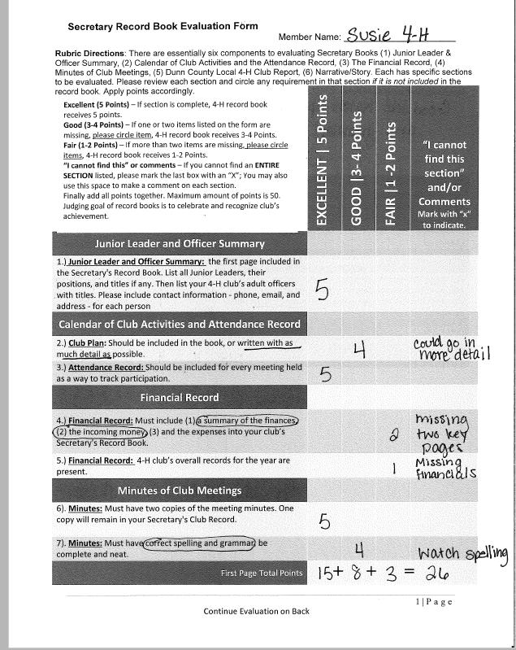
SAMPLE EVALUATION FORM

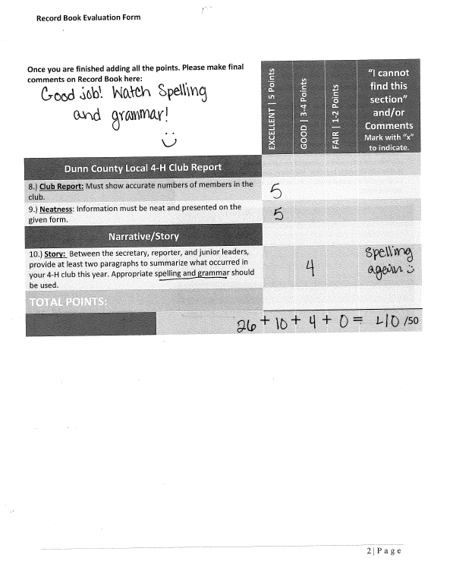
SAMPLE EVALUATION FORM

