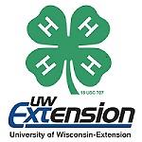

Building Life Skills in Action

Youth can build life skills through 4-H Youth Development. Let’s take a closer look and determine what life skills are happening in all of these scenarios:

- A committee of young people from a local group is planning a community service project. They have met and have a variety of ideas and need to come to a consensus.

- The Busy Beavers February 4-H Club meeting focuses on the “HEART”. The guest speaker is a doctor showing a demonstration of a heart, the snacks are heart healthy treats and cards are being made for area nursing home residents.

- A three-day camp is an important program in King County. Camp counselors and adult volunteers are necessary for a successful camp program. The youth and adult volunteers can’t agree on the evening camp program.

