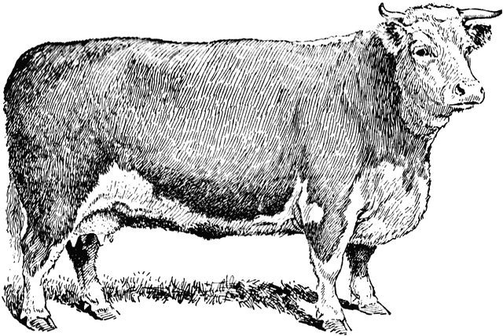**DUNN COUNTY MEAT ANIMAL PROJECT**

***BEEF* – 2020 ENTRY FORM**

**Individual or Family Names:**

**_____________________________ _______________________________________**

**______________________________ _______________________________________**

**______________________________ _______________________________________**

**Club: _______________________________________________________________________**

**Parents/Legal Guardian Name as it will appear on sale bill:**

____________________________________________________________________________

**Address/City/Zip:** _____________________________________________________________

**Phone (please include cell # if applicable):**________________________________________  
**Would you like to receive Text Messages related to the Meat Animal Project?**

**YES NO**

**E-mail:** ___________________________________________________________

|  |  |  |  |
| --- | --- | --- | --- |
| **Yellow Dunn Tag**  **(example – 5000)** | **Other Tags**  **(example 840)** | **BEG. WEIGHT**  **(Note: optional / required for total performance)** | **Species / Class**  **Single, Cross, Dairy, Heifer** |
|  |  |  |  |
|  |  |  |  |
|  |  |  |  |
|  |  |  |  |
|  |  |  |  |

*I have read and understand the rules put forth by the Dunn County 4H/FFA Meat Animal Committee and agree to abide by these rules.*

**Signatures**

Parent/Guardian: _______________________________________

Member: _______________________________________

Member: _______________________________________

Member: _______________________________________

Member: _______________________________________

Member: _______________________________________