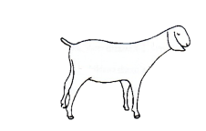
DUNN COUNTY MEAT ANIMAL PROJECT
Goat – 2020 ENTRY FORM

Individual or Family Names:

______________________________ ______________________________________
______________________________ ______________________________________
______________________________ ______________________________________
Club: ____________________________________________
Parents/Legal Guardian Name as it will appear on sale bill:
_________________________________________________________________
Address/City/Zip: __________________________________________________
Phone (please list cell# if applicable): __________________________________
Would you like to receive text messages related to the Meat Animal Project?
YES NO
E-mail: ___________________________________________________________
Yellow Dunn Tag (example: 5000) | Other Tag  or identifier | Beginning Weight  Note: optional/required for total performance | Male/Female

I have read and understand the rules put forth by the Dunn County 4H/FFA Meat Animal Committee and agree to abide by these rules.

Signatures:

Parent/Guardian: ____________________________________________________
Member: ____________________________________________________
Member: ____________________________________________________
Member: ____________________________________________________
Member: ____________________________________________________
Member: ____________________________________________________

