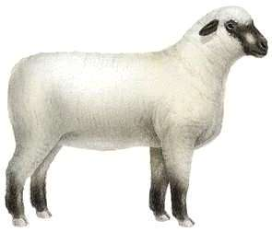
DUNN COUNTY MEAT ANIMAL PROJECT
SHEEP – 2020 ENTRY FORM

Individual or Family Names:
______________________________ _________________________________
______________________________ _________________________________
______________________________ _________________________________
Club: __________________________________________________________________
Parents/Legal Guardian Name as it will appear on sale bill:
__________________________________________________________________
Address/City/Zip: ___________________________________________________
Phone (please list cell# if applicable): __________________________________
Would you like to receive text messages related to the Meat Animal Project?
YES NO
E-mail: ___________________________________________________________
Yellow Dunn Tag (example: 5000) | Other Tag  (example: Scrapie Tag) | Beginning Weight  Note: optional/required for total performance | Ewe / Whether

I have read and understand the rules put forth by the Dunn County 4H/FFA Meat Animal Committee and agree to abide by these rules.

Signatures:
Parent/Guardian: ____________________________________________________
Member: ____________________________________________________
Member: ____________________________________________________
Member: ____________________________________________________
Member: ____________________________________________________
Member: ____________________________________________________

