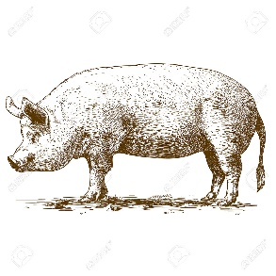
DUNN COUNTY MEAT ANIMAL PROJECT
Swine – 2020 ENTRY FORM

Individual or Family Names:

______________________________ __________________________________
______________________________ __________________________________
______________________________ __________________________________
Club: ___________________________________________________________________
Parents/Legal Guardian Name as it will appear on sale bill:
________________________________________________________________________
Address/City/Zip: _________________________________________________________

Phone (please list cell# if applicable): __________________________________
Would you like to receive text messages related to the Meat Animal Project?
YES NO
E-mail: ___________________________________________________________
Yellow Dunn tag # (example: 5000) | Other Tag (or identifier like ear notch) | Pure breed /  Cross breed | Barrow / Gilt

I have read and understand the rules put forth by the Dunn County 4H/FFA Meat Animal Committee and agree to abide by these rules.

Signatures:
Parent/Guardian: ____________________________________________________
Member: ____________________________________________________
Member: ____________________________________________________
Member: ____________________________________________________
Member: ____________________________________________________
Member: ____________________________________________________

