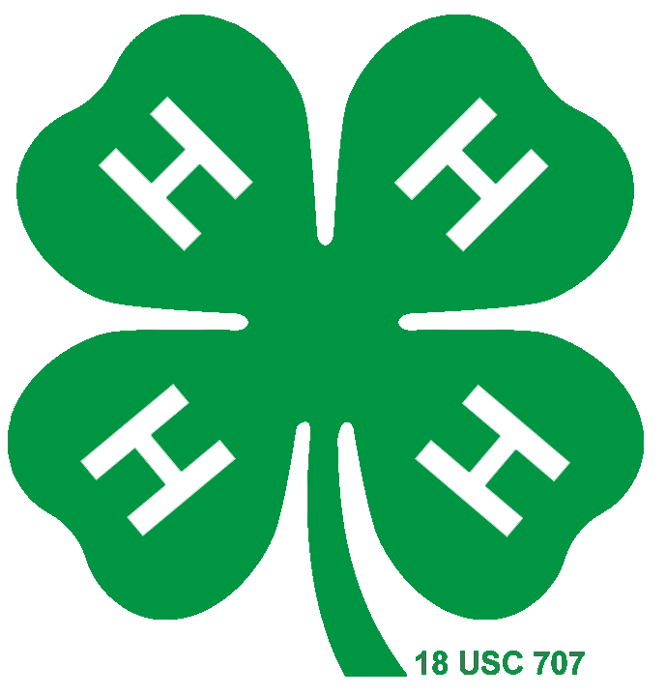
Insert your Photo here

Dunn County
4-H MEMBER
Yearly Plan and Record Book

Name:
Club Name:
4-H Participation
Year | Age | Grade | Years in 4-H  Cloverbuds + this year | Club Meetings
 |  |  |  | # Held | # I Attended
Age is as of October 1st (4-H Calendar Year) and grade is the last year completed.

Plaque disc you’re applying for:
County project award(s) you’re applying for:

