• A webinar series for farmers and agronomy professionals where participants learn about on-farm research design to improve cropping system decisions and increase profitability. (Jerry Clark, Abby Augarten, Lindsey Rushford)
Agriculture

Jerry Clark | Regional Crops & Soils Educator
Sign up to receive the Extension in the Valley agriculture and horticulture e-newsletter HERE .

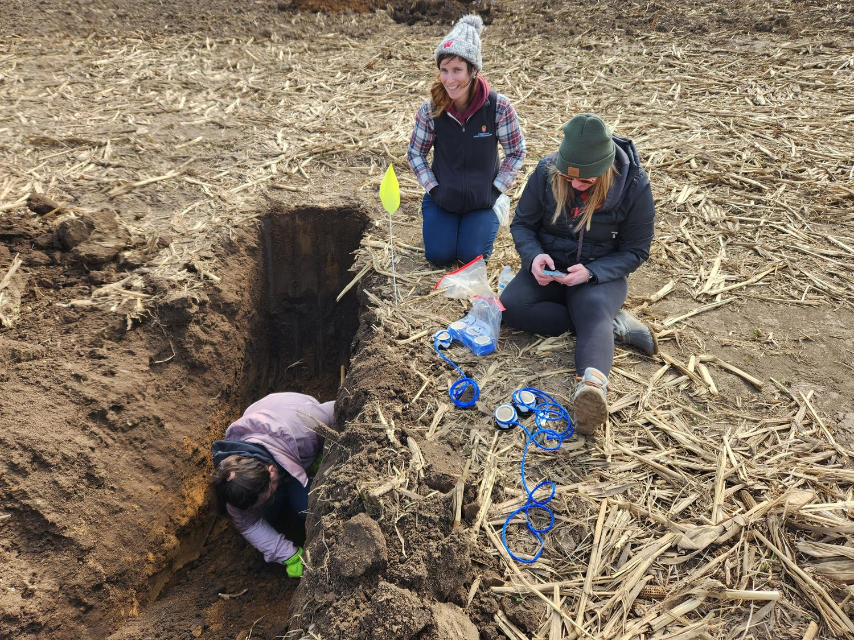
An on-farm research study to better understand manure application, commercial nitrogen application rates, and nitrogen credits on corn yield and potential effect on groundwater. Results from this study will help farmers, agriculture industry and agency professionals in adjusting manure and commercial nitrogen applications to optimize corn yield and protect groundwater resources. In the photo to the right, Nitrate monitoring lysimeters are being installed at a Nitrogen Optimization Pilot Program in Chippewa County. (Partnered with: Amber Gilles, Christine Clark, Jordan Kampa, Joshua Kamps, Kelsey Hyland, Kristin Peterson, Lindsey Rushford, Liz Gartman, Melissa Ohlrich, Ryan Sterry, Scott Reuss, Steven Hall, Teal
Polzin)

A webinar series for farmers and agronomy professionals where participants learn about on-farm research design to improve cropping system decisions and increase profitability. (Hosted with: Abby Augarten, Lindsey Rushford)

Spotlight
Manure and commercial nitrogen fertilizers are sources of nitrogen for corn production. Use of nitrogen fertilizers and manure in agriculture production fields is needed for higher crop yields. Over application of nitrogen and manure can lead to nitrate nitrogen leaching to groundwater. Groundwater quality is a major concern across Wisconsin counties. Funding through a Nitrogen Optimization Pilot Program On-Farm Research grant led to investigation of the effect of manure and commercial nitrogen application on corn yield on six farms across Wisconsin. Farmers and Regional Educators are collaborating to implement on-farm research to discover yield and water quality effects of various rates of nitrogen to areas of fields with and without applied manure. The purpose of the project is to understand how manure application impacts the Maximum Return to Nitrogen (MRTN) for corn throughout the growing season. The research seeks to validate the recommended manure nutrient credits and MRTN values for corn. Participating farmers and extension educators anticipate there will be an increase in yield for plots with manure and nitrogen applied, but a lower crop response to nitrogen as the amount of nitrogen applied increases. This would allow manure sample data to be utilized to correlate total amounts of nitrogen received for each plot to the harvested yield. Six rates of nitrogen from 0, 40, 80, 120, 160, and 200 pounds per acre are applied with four replications at six farms across Wisconsin. Water quality measurements through lysimeters installed at one location will assist in evaluating the movement of nitrogen through the water profile. Lysimeters installed in April 2024 were removed in April 2025 and nitrate results are currently being analyzed. This is the second year of a two-year project to be completed in fall of 2025 with results to be released in Spring 2026
Ryan Sterry | Regional Livestock Educator

Chippewa Valley Forage Council Spring Seminar for Beef and Dairy Forage producers. Extension Regional Educators Jerry Clark and Ryan Sterry, and Outreach Specialists Leonard Plzien and Bill Halfman, addressed current forage, beef, and dairy production topics for the 2025 Chippewa Valley Forage Council Spring Seminar
Presentations and discussions included an update on producer-led watershed grant programs, a dairy market outlook, nutrition considerations for the beef cow herd, transitioning to beef: considerations for cattle handling, nitrogen management research, and Inter-seeding alfalfa with corn silage. For Ryan’s presentation, Transitioning to Beef: Considerations for Cattle Handling, participant evaluations showed a +1.5 gian in knowledge (5 point scale) (In partnership with: Bill Halfman, Jerry Clark, Leonard Polzin)
An article for beef cow-calf producers where readers learned the value of crossbreeding and how it can be implemented on their farms to help them improve profitability. (Collaborated with: Bill Halfman, Beth Mcilquham, Kimberly Kester)
A series of workshops for beef producers where producers learned about what type of cattle packers prefer to meet consumer demands, what quality and yield grades are, current challenges in the beef industry and best management practices to produce ideal market animals. (Beth Mcilquham, Bill Halfman, Kimberly Kester, Ryan Sterry)
Spotlight
The traits of fed cattle influence what beef processors are willing to pay for them. These differences can result in substantial differences in prices paid. Producers do not always get feedback on the animals they sell or get to hear directly from the beef processors on the type of animals they prefer, primarily due to the segmentation of the industry. Wisconsin has seen steady growth in the number of producers. Auction managers and other industry professionals have indicated that some producers are selling high-quality animals, and others have room for improvement, which would help their profitability and sustainability. Best management practices are critical to produce high-quality beef animals for market. High-quality beef animals are often defined by quality and yield grade, however, these topics are often not given as feedback to producers. The 2022 Beef Quality Audit identified what is going well in the beef industry and where there is room for growth and education. Providing this information can help cattle feeders evaluate their operation and management to make improvements. UW Extension collaborated with the Wisconsin Beef Council and the Wisconsin Department of Agriculture to organize and conduct workshops at 3 locations around the state to provide beef producers the opportunity to learn about what ideal market animals look like, what meat quality and yield grades are and management practices to produce quality animals. Organizing partners created a safe space for producers to ask questions to a packer representative. One-hundred-sixty people attended the workshops and evaluations were returned by 67 participants. Of those who responded, 37 indicated that they planned to implement changes to their production based on changes learned at the workshop. Across all topics, the average percent increase in knowledge was 39%. On a Likert scale of 1 to 5, their average knowledge increase was 1.12 points across all topics. Some of the top responses to a question referencing what they learned included hearing from the buyers about what they are looking for, quality and yield grade, the results from the most recent beef quality audit, bruising, and carcass defects, factors that influence meat that is dark, firm, and dry, the importance of feeding, bunk management, and keeping cattle clean.
Horticulture
Margaret Murphy | Regional Horticulture Educator
Extension in the Valley agriculture and horticulture e-newsletter, view newsletters HERE .
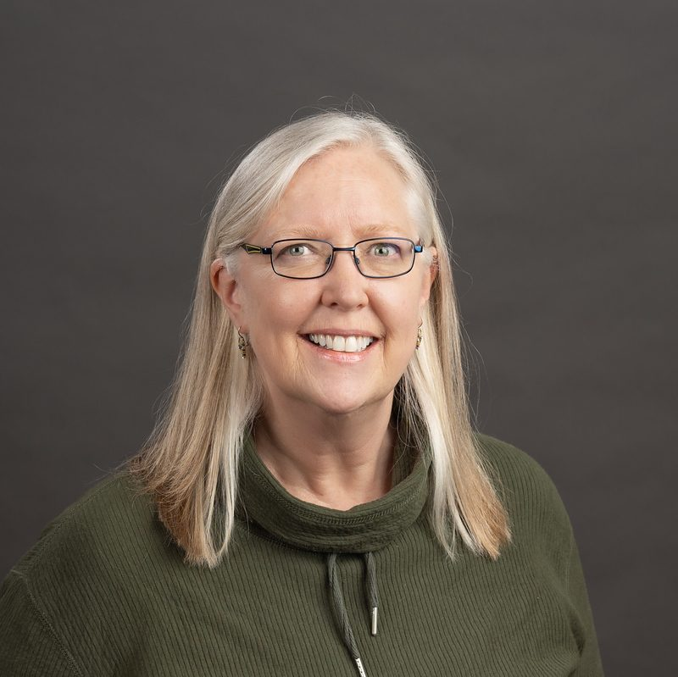
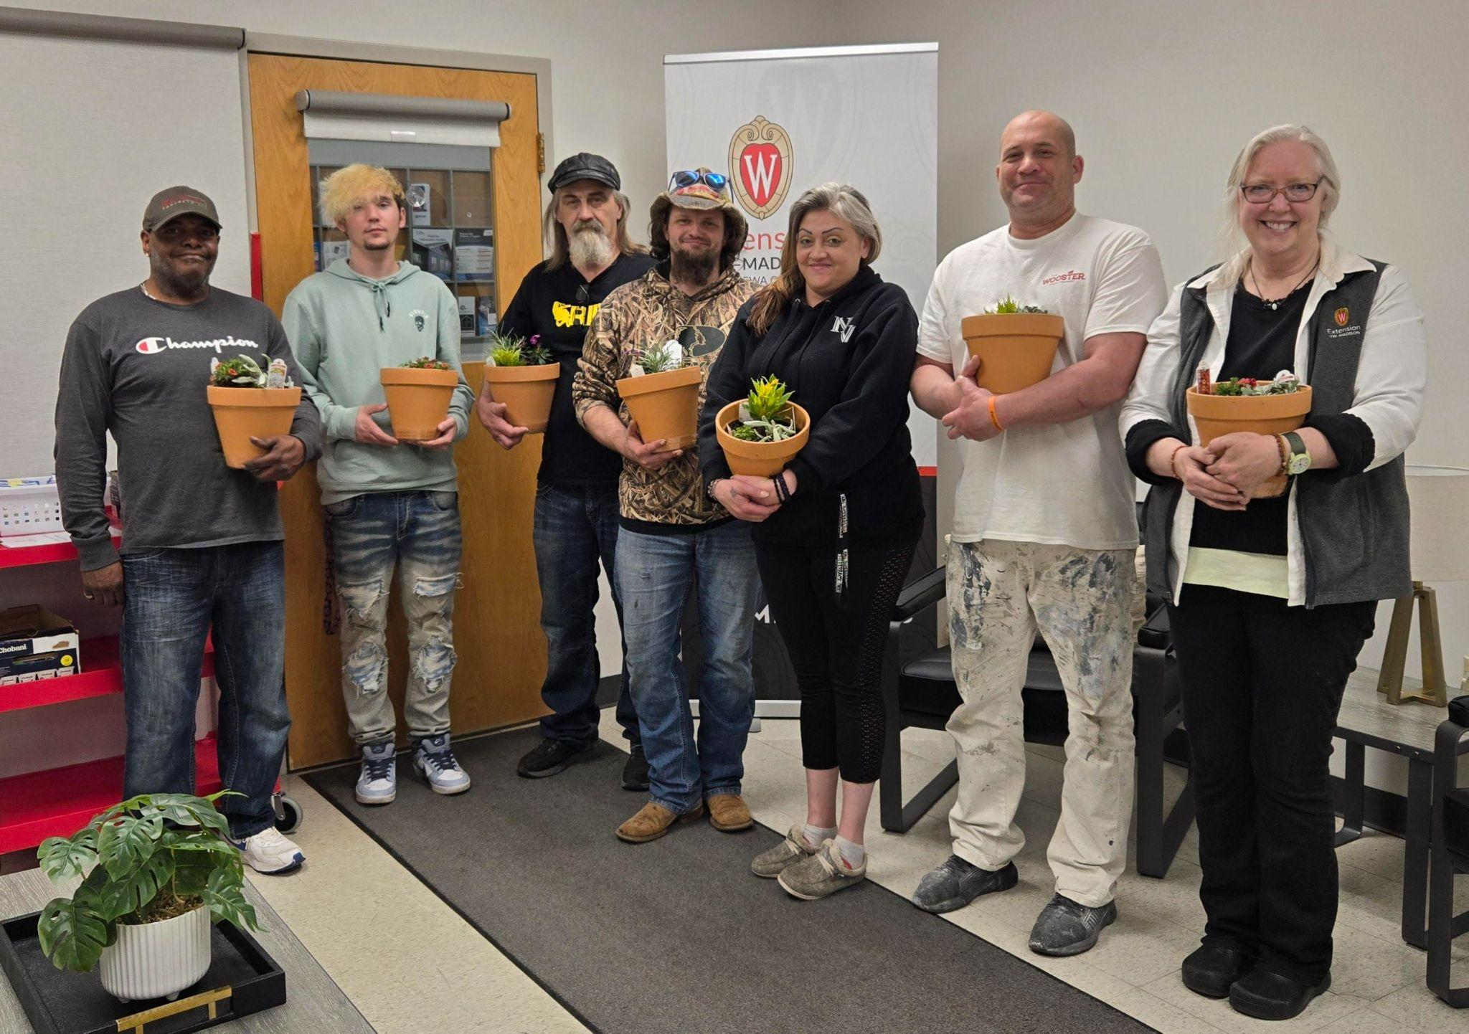
An activity to illustrate the wellness benefits of gardening for participants in the Chippewa County Recovery Court Program. Participants learned how gardening is a great way to incorporate many wellness benefits such as stress relief, focus recovery and a sense of accomplishment into your life and were able to build their own sensory garden in a pot. This effort was designed to encourage people to include plants and gardening in their lifestyle to experience the many benefits that gardening can provide. (In collaboration with Jeanne Walsh)
A program for the public on growing fruit in containers where participants learned best practices on container gardening together with guidance on fruit selections for containers. This effort was designed to encourage people of all ages to eat garden food even if space or mobility is limited.
Provided garden articles and factsheets for the public in the Extension in the Valley, a tri-county monthly newsletter that focuses on Agriculture and Horticulture news. Included were gardening tips for older adults, tips on gardening with kids, and links to UW Madison Extension articles on seed starting, early spring lawn care and pruning evergreen shrubs. Links to the PDDC current blog and upcoming garden events were also included. This effort is designed to keep participants connected to seasonal horticulture topics. (Partnered with: Amber Gilles, Jerry Clark, Ryan Sterry)
A program for the public on common diseases, pests and disorders that they may encounter in the gardens this summer. Participants learned what signs / symptoms to look for and corresponding management strategies based on IPM techniques. This effort was designed to encourage people to stay observant in the garden for early detection of an issue and properly identify and understand the issue before making management decisions.
A garden program for beginners where participants learn the basics of vegetable gardening. The goal of this effort was to teach those new to vegetable gardening how to start a vegetable garden, understand soil health, learn about plant selection, planting, and garden maintenance.
Spotlight
Finishing up the third year of a spring gardening series in partnership with a local library. As previous programs have centered on fruit, vegetable and small space gardening, programs for this year focused on how to manage pests, disease and disorders that may occur in the summer garden plus, guidance on food safety in the garden for donating produce to area food pantries.
Community Development
Garret Zastoupil | Regional Community & Leadership Development Educator

A 4-part workshop series in partnership with Wisconsin Literacy where board members and directors of small literacy organizations evaluate the current state of their organization, analyze support pools for volunteers and funding, and create action plans to ensure their organization is sustainable over time. (Partnered with: Sarah Schlosser, Alyson Sauter, Barbara Alvarez)
Continued development of the Chippewa Valley Health Cooperative and its efforts to re-open the former St. Joseph's Hospital in Chippewa Falls as an full-service interim healthcare facility, and to build a new full-service hospital in Lake Hallie, Wisconsin to replace the 34% of regional health care lost with the closure of the two HSHS hospitals in Eau Claire and Chippewa Falls and 19 Prevea clinics across the region. (In collaboration with: Bill Oemichen, Karl Green, Kristen Bruder)
Facilitated a series of meetings to support the Town of Elk Mound's development and submission of an Innovation Planning Grant with the Wisconsin Department of Revenue that will hire a consultant to examine opportunities to strengthen fire and emergency medical services in Dunn County. The Town of Elk Mound was awarded the grant for $52,500 and the educator will continue to support the Town of Elk Mound and consultant in the development of a report and community conversations following its release. (Facilitated with: Karl Green)
Co-Chairing the Childcare Action Team with Health Dunn Right, guiding a new group to identify its mission and goals, and development and implement an action plan. The goal of the group is to support affordable, accessible, high-quality childcare in Dunn County by bringing together a variety of partners from the business, education, and nonprofit communities.
Spotlight
The 2024 Dunn County Community Health Needs Assessment identified Childcare as a top need in Dunn County. The Dunn County Human Development and Relationship Educator approached the Community and Leadership Development Educator about co-chairing a new Childcare Action Team with Health Dunn Right, the coalition group that leads the Community Health Improvement Plan. As a new group and an issue that is essential to community vitality, it was important for the educator to step into this role. The educator has lead a new group through a strategic doing process that allowed the action team to set goals and action plans.
Health and Well-Being
Sandy Tarter Joy Weisner Hillarie Roth
FoodWIse Coordinator FoodWIse Educator FoodWIse Educator
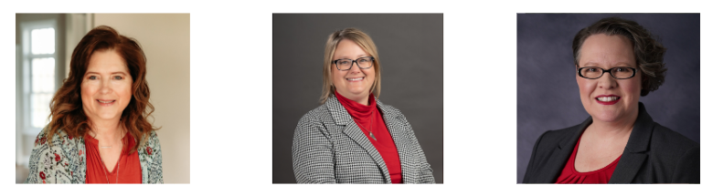
Collaboration with Indianhead Enterprises where Kalina Kline gave a presentation to Extension for connection and relationship building. FoodWIse team is planning a tour at their facility and to discuss possible future programming. This effort would enhance the life skills for adults with varying intellectual and developmental abilities.
A series of virtual strength training sessions (StrongBodies) for adults in the community, where participants engage in regular, progressive strength training and health education to improve their physical and mental health, and enhance social connectedness.
Spotlight
Studies on teaching young children about fruits and vegetables consistently demonstrate that repeated exposure, positive experiences, and engaging activities, like gardening and cooking, are key to fostering healthy eating habits. Early introduction to a variety of fruits and vegetables, combined with education and positive reinforcement, can significantly impact children's preferences and consumption of these foods. FoodWIse education incorporates the following key findings and messages (Part 1):
Repeated Exposure and Positive Experiences:
Taste exposure: Repeatedly offering children new fruits and vegetables, even if they initially dislike them, can lead to increased acceptance and liking. Their taste buds are growing and changing with their bodies!

Positive mealtime environment: Creating a fun and supportive environment around meals, free from pressure to eat, can encourage exploration of new foods. We like to encourage the “Smell it, Lick it, Bunny bite it method in our classrooms!

Involvement in food preparation: Activities like gardening, cooking, and taste-testing can enhance children's interest and willingness to try new fruits and vegetables. We provide age appropriate activities in the kitchen to help Mom or Dad with food preparation. Even a 2 yr old can wash fruits and veggies or tear lettuce!
Human Development and Relationships
Luisa Gerasimo | Human Development and Relationships Educator
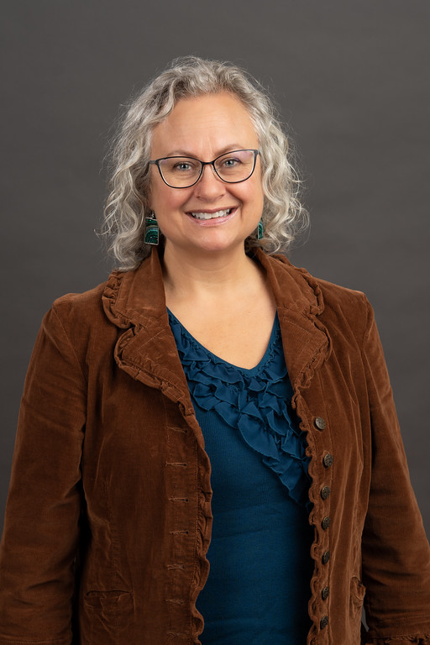
Created bilingual outreach materials for Spanish-speaking families. The goal was to adapt existing Just In Time Parenting Newsletter resources, so that they are accessible to Spanish speaking families, helping more families access timely, research-based parenting information in their preferred language. (Created with Alicia Utke-Becher)
Dunn County Human Services Division staff meeting: I addressed parenting challenges and resources available to the staff themselves as parents, and their clients were shared. The goal of the presentation was to share what Extension may be able to provide to staff and clients of the division.
Raising A Thinking Child: A 6-session online class for parents of children aged 4-7 years old. Tools for encouraging children to understand their emotions and make better choices were shared so that families experience better communication and behavior. (Hosted with Missy Bablick) See testimonial below.
Parents Forever: This month I held a four-hour in-person class on a Saturday morning. Two of the parents spoke English as a second language and were not able to take the online version we offer every other month due to lack of technology. This class helps parents learn skills to prioritize the parent-child relationship and better communicate with their co-parent. The program is designed to increase child well-being and reduce parental conflict during family transitions.
Quarterly newsletter for families and family-serving professionals: part of the newsletter included a detailed explanation of the importance of connection and reconnection for babies and young children. Through this effort important academic research is explained and shared at a level where it can be used on a daily basis. See spotlight below.
Free books for local families: Last month, I connected a number of partners to initiate a donated children's book bin to encourage families to read together while waiting for county appointments and allow children to select a book to take home. The bin was restocked in April as families had removed a significant number of children's books. Let me know if you have kids’ books you would like to donate.
Resilient Co-Parenting: A monthly topic-specific series for parents and caregivers experiencing separation, divorce, or changes in the custody of their children, where they learn skills to improve communication and problem-solving, support children emotionally, and keep kids out of the middle of conflict. This series is co-taught by educators from across Wisconsin and is designed to improve understanding of positive parenting practices that are useful during stress, while providing social connections for parents experiencing family transitions. (In collaboration with: Hannah Zellmer, Adam Trunzo, Amanda Griswold, Beverly Doll, Heidi Ungrodt, Mary Campbell Wood, Missy Bablick, Pamela Wedig-Kirsch, Pattie Carroll, Renee Koenig, Todd Wenzel, Tracy Henegar)
Testimonial
“This is really a wonderful and helpful class. The six-week class gave an opportunity to learn, practice, and reinforce the ideas. It also helped me to reflect on myself, not only to be a better parent, but also to be a better myself. Both instructors created a very friendly, supportive and encouraging learning environment. I feel supported and really appreciate them. I already recommended this class to my friend. Thank you!!” -- parent in Raising A Thinking Child class
Spotlight
Connection and Reconnection: For decades researchers have told us that we must spend time responding to the needs of our little ones. This is how they become attached to us and learn to feel safe in the world. Recently, researchers noted that while we cuddle, read, sing to and play with our babies, caregivers often need to disconnect to do a short task. What happens next is key. When parents reconnect, researchers see even stronger bonds being built between the caregiver and the baby. Who among us has not had to turn away from a baby to buckle up a toddler, or clean up a sudden mess? The key thing is to communicate what you are doing and then reconnect.
Children who are lucky enough to have this connection, and reconnection with a loving adult, are likely to feel more comfortable in the larger world, because not only have they bonded, they have also learned it is ok to take little breaks from the connection to a loved one and be rewarded with feeling that bond again. Because my newsletter has a bigger reach than any other outlet for sharing information like this, I typically reserve about 1/3 of the space for an educational topic. In the Spring Newsletter I shared research on connection and reconnection. Many of the people on my emailing list work for childcare centers, schools, churches and libraries, so sharing the power of connection and reconnection is important since they work with hundreds of families each year.
Positive Youth Development
Zachary Rozmiarek | 4-H Program Educator
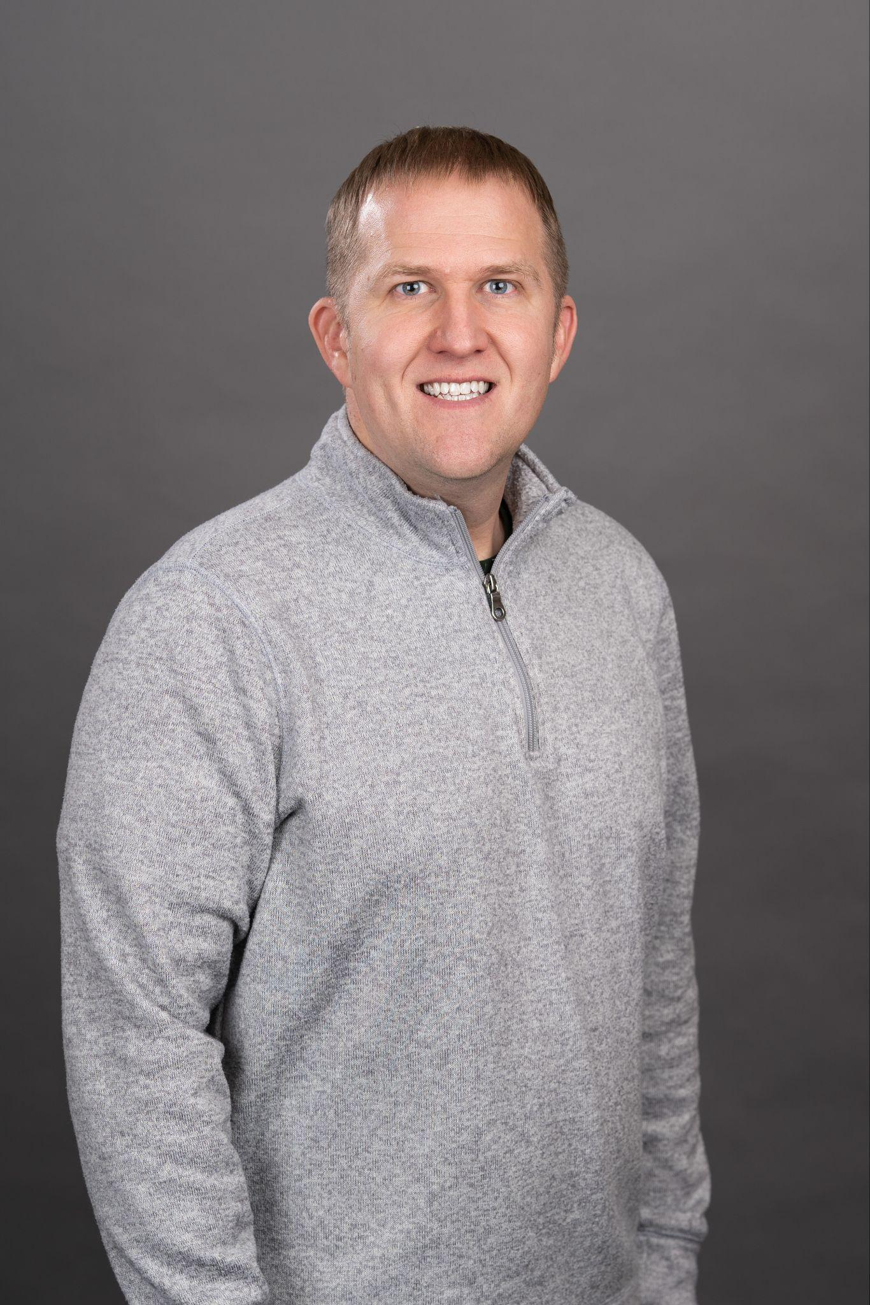
The May Clover Courier can be viewed HERE
On April 7th, Zac welcomed a new addition to his family—a baby boy named Calum. Zac will be on paternity leave through May 19th as he enjoys this special time with his family. In Zac’s absence, Ann Lee, 4-H Program Assistant, has stepped in to ensure the continued success of our 4-H programs. Under Ann’s leadership, the 4-H Robotics Day was held at UW–Stout, and a Cat Project meeting was successfully hosted. Additionally, in celebration of Volunteer Appreciation Month this April, Ann prepared and coordinated the mailing of appreciation gifts for all of our dedicated 4-H volunteers.
A Camp Orientation Zoom where campers and their parents could see pictures of camp, hear expectations for campers and parents, and ask questions. Camp orientations have been shown to reduce anxiety about participating at camp. (Partnered with: Rachel Hart-Brinson, Seth Harrmann)
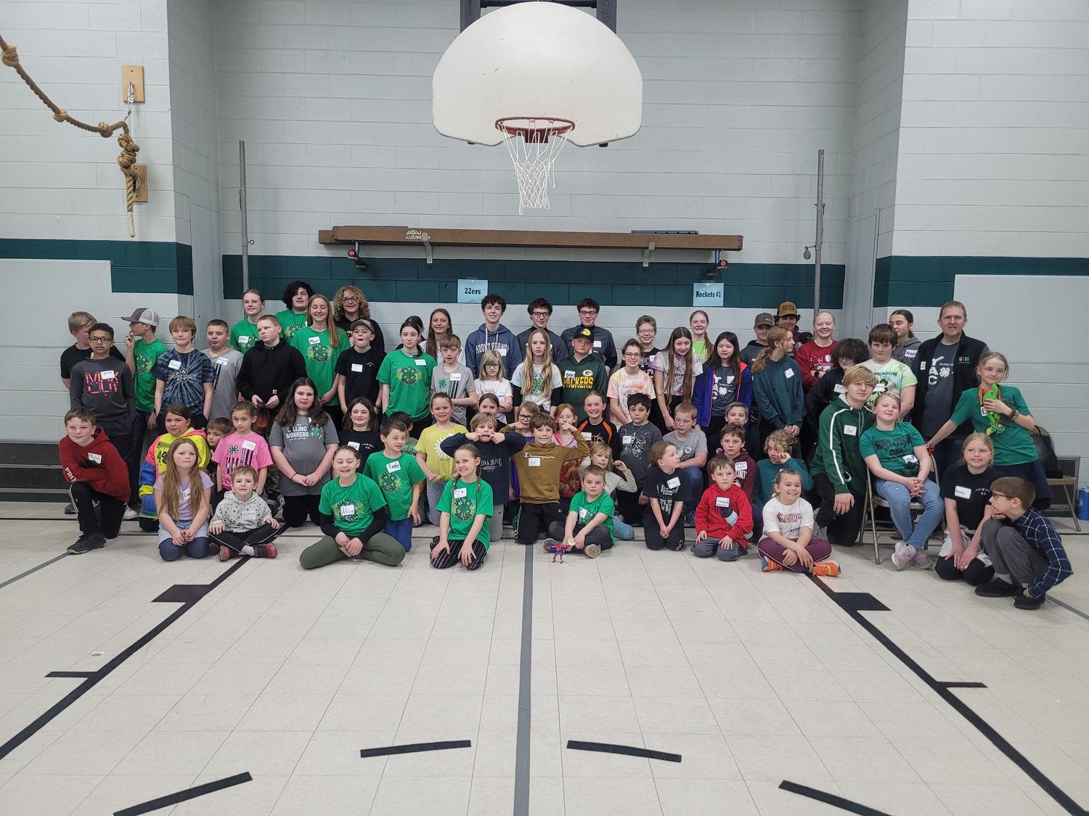
Preparation for Camp Counselor training on May 4. This training will allow young people an opportunity to practice their sessions that they will lead at camp as well as cover some leadership strategies and self reflection that they will use when they are at camp. (Prepared with: Rachel Hart-Brinson, Seth Harrmann)
The 2025 Battle of the Clubs was held last month. We had 8 clubs participate with about 78 youth in attendance. The Youth from the Youth Activities Council led short competitions for the clubs to compete in. There were also activities to get the youth to meet someone from another club. The event ended with a pizza party!
Spotlight
The county 4-H members were looking for a way to engage with youth from other clubs. We also saw the need to come together and build belonging amongst the county. A final need was offering the older youth a chance to gain leadership skills. Putting on the Battle of the Clubs served all of the needs that were present. Including activities that allowed youth to meet and connect helped to build the belonging and create connections across the county. The older youth planned the event and led the activities. This gave them the opportunity to gain leadership skills. Throughout the event I saw the youth become more comfortable with each other. It was obvious that they created connections that they did not have before. I also had youth tell me that because of this event, they are more likely to participate in other county-wide activities.
Value Added Programming
An online learning opportunity for Entrepreneurs in Training (EITs) and volunteer business leaders to collaborate on developing stronger business plans. This structured interaction builds confidence and entrepreneurial skill in the EITs and fosters empathy and confidence for volunteers that formerly incarcerated entrepreneurs can contribute positively and move our communities forward after prison. (Diana Hammer, Erin Rivera, Michael Senn)

A Mental Health Training Request Form, where members of the public and community partners can request training for their group in Eau Claire, Chippewa, and Dunn Counties. The goal is to have a central location for tracking mental health training requests in the Chippewa Valley and work with community partners to efficiently fill training needs. (Margo Dieck)
Area Extension Director
Kristen Bruder | Area Extension Director – Dunn, Chippewa, and Eau Claire Counties

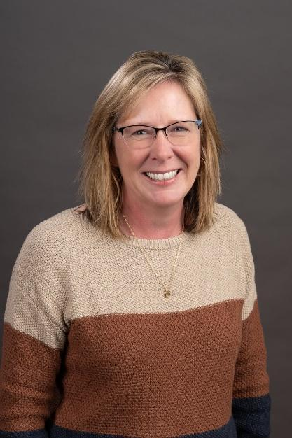
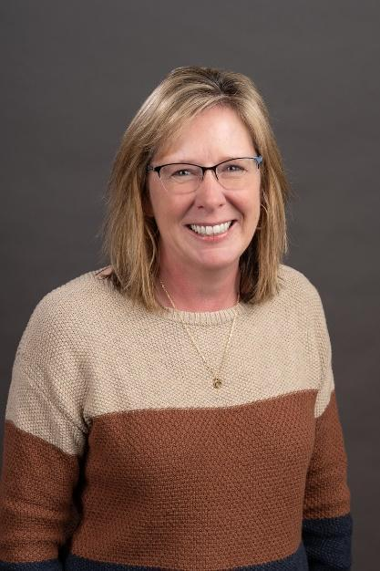
Please reach out with questions and ideas. The role of the AED is much like the department head in the county. Below is a brief overview of the role of AEDs: Extension fully invests in Area Extension Directors (AEDs) who oversee an area. These administrative positions are responsible for partnership management, staff development, financial management and program coordination.

Through the many interactions the AED has with county partners and local educators, the AED develops a solid understanding of the local needs and county priorities and helps to align Extension educational programs to ensure the programs address county needs. Educators also communicate local needs to their programmatic Institutes which collectively identify opportunities to address statewide needs.

Upcoming events
Event Calendar – Extension

Dunn County Extension in the News
Margaret Murphy: https://www.weau.com/2025/04/02/growing-extra-food-share-with-local-food-pantries/

Jerry Clark:
https://www.weau.com/2025/04/08/federal-cuts-could-affect-research-through-usda/

