• A webinar series for farmers and agronomy professionals where participants learn about on-farm research design to improve cropping system decisions and increase profitability. (Jerry Clark, Abby Augarten, Lindsey Rushford)
Agriculture

Jerry Clark | Regional Crops & Soils Educator
Sign up to receive the Extension in the Valley agriculture and horticulture e-newsletter HERE .

A series of alfalfa measurements that will help to better understand optimum alfalfa and winter cereal harvest across Wisconsin. The results of this study will help forage growers to determine what techniques can best predict optimum forage harvest timing to improve first cutting forage quality for livestock. (In collaboration with: Liz Gartman, Aerica Bjurstrom, Anastasia Kurth, Angie Ulness, Jackie Mccarville, Jordyn Sattler, Kevin Jarek, Scott Reuss)

Spring alfalfa quality monitoring, utilizing scissors clippings for lab analysis and PEAQ stick measurements (Predictive Equations for Alfalfa Quality), was an effort to increase awareness of Extension resources on forage quality and local forage crop conditions. This effort for farmers and agribusiness professionals was aimed at improving forage quality and yield, thereby improving farm profitability. (Partnered with: Ryan Sterry)
An on-farm research study to better understand manure application, commercial nitrogen application rates, and nitrogen credits on corn yield and potential effect on ground water. Results from this study will help farmers, agriculture industry professionals, and agency professionals in adjusting manure and commercial nitrogen applications to optimize corn yield and protect groundwater resources. (With help from: Amber Gilles, Christine Clark, Jordan Kampa, Joshua Kamps, Kelsey Hyland, Kristin Peterson, Lindsey Rushford, Liz Gartman, Melissa Ohlrich, Ryan Sterry, Scott Reuss, Steven Hall, Teal Polzin)
Spotlight
First crop alfalfa cutting tends to represent the largest quantity of forage yield for the year, representing approximately 36-41% of total dry matter (DM) yield. When harvested in a timely manner, it can result in high levels of neutral detergent fiber (NDF) digestibility while still meeting yield goals. Mismanaging first crop forage harvest timing creates challenges for the farm. Too early harvest leads to lower yield and extremely high-quality forage which some farms may struggle to properly utilize in their ration. Later than optimum harvest yields distinctly lower forage quality and may jeopardize a farm's plan for future harvest events. There is a diverse network of forage-focused staff at the University of Wisconsin-Madison, Division of Extension that have led the effort to track, report, and record alfalfa quality using Predictive Equations for Alfalfa Quality (PEAQ) and correlate with lab analyzed scissors cut results. Some regional educators have the financial support of local forage councils (including Manitowoc, Fond du Lac, Chippewa Valley, Outagamie, and Shawano), agribusinesses and other grower groups to fund lab testing, others lack this financial support, hampering the uniform collection of laboratory tested forage sample data. Requested grant funding would allow educators across the state to standardize the collection of PEAQ stick measurements, crop stage, and height, as well as the collection of samples for submission to certified forage testing labs. The effort would include both alfalfa and winter annual cereal crops, with most data collection occurring within alfalfa. A uniform statewide effort results in greater understanding and correlates relationships between PEAQ measurements and relative forage quality (RFQ) from lab reports in various growing regions across Wisconsin allowing for the development of future predictive tools to improve grower forecasting and decision-making capability.
Ryan Sterry | Regional Livestock Educator

A series of introductory videos introducing regional livestock educators to provide examples of livestock area programs to county partners and public stakeholders. (Developed with: Beth Mcilquham)
In an effort to identify host sites for field day programs and demonstrations, Ryan has continued to meet with livestock producers, public agencies, and agribusinesses in the Chippewa Valley.
Spring alfalfa quality monitoring, utilizing scissors clippings for lab analysis and PEAQ stick measurements (Predictive Equations for Alfalfa Quality), was an effort to increase awareness of Extension resources on forage quality and local forage crop conditions. This effort for farmers and agribusiness professionals was aimed at improving forage quality and yield, thereby improving farm profitability. (With: Jerry Clark)
Horticulture
Margaret Murphy | Regional Horticulture Educator
Extension in the Valley agriculture and horticulture e-newsletter, view newsletters HERE .
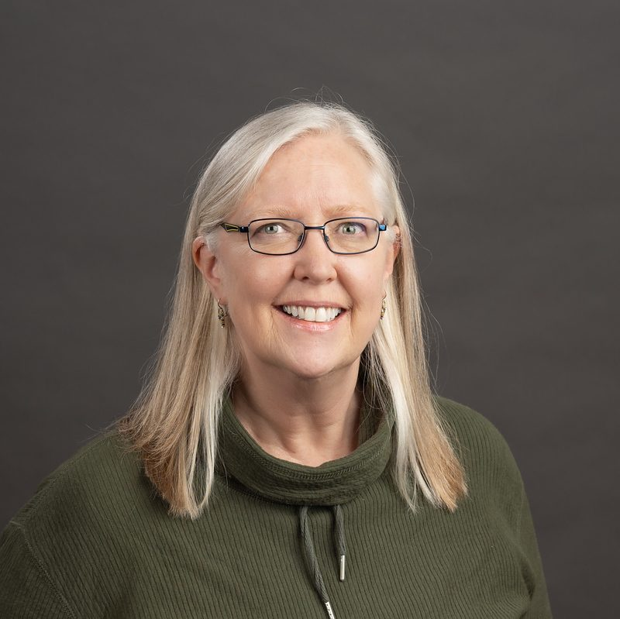
A program on adaptive gardening for participants of two StrongBodies classes where participants learn about strategies and techniques that help us to continue to garden safely as we age. (Partnered with: Karie Johnson, Mary Hoeft-Leithold, Sandy Tarter)
Prepared and continue to manage three local community gardens for the public where participants can grow vegetables and fruits to save money, participate in learning opportunities and be part of a garden community to enhance positive socialization. (In collaboration with: Amber Gilles and Andy Heren, Kristi Peterson)
A garden program for beginners for participants of Affinity House where participants added warm season crops to the garden and learned about strategies for small space gardening. The goal of this effort is to teach those new to vegetable gardening about plant selection, interplanting and other techniques for gardening in a small space and garden maintenance. (Partnered with: Sandy Tarter)
A garden program for youth in partnership with the Dunn County Department of Human Services where participants mapped their garden, planted vegetable crops, learned about plant selection, small space gardening techniques and garden maintenance.
Staffed a UW Madison Extension booth at a free annual event hosted by a local museum. This year’s theme was plants and insects. Information on native plants and pollinators was provided for participants to learn the value of creating ecological niches using native plants allowing urban areas to support a host of different insect pollinators. This effort is to encourage individuals to adopt gardening practices that support pollinator habitat and health throughout the year.
Spotlight
Participation in this activity was a result of a request from the museum. wanting to involve UW Madison Extension and learn more about our horticultural services and information available to the public. I provided handouts, set up an interactive game for kids and was available for questions and networking
Community Development
Garret Zastoupil | Regional Community & Leadership Development Educator

Strategic planning for a community-serving organization where we updated the organization's mission and vision statement, identified goals, and developed action plans. The planning process is intended to clarify the organization's purpose and develop achievable steps to realize its vision.
Facilitated a series of meetings to support the Town of Elk Mound's development and submission of an Innovation Planning Grant with the Wisconsin Department of Revenue that will hire a consultant to examine opportunities to strengthen fire and emergency medical services in Dunn County. The Town of Elk Mound was awarded the grant for $52,500 and I will continue to support the Town of Elk Mound and consultant in the development of a report and community conversations following its release. (In collaboration with Karl Green)
Co-Chairing the Childcare Action Team with Health Dunn Right, guiding a new group to identify its mission and goals, and development and implement an action plan. The goal of the group is to support affordable, accessible, high-quality child care in Dunn County by bringing together a variety of partners from the business, education, and nonprofit communities.
Spotlight
The 2024 Dunn County Community Health Needs Assessment identified Childcare as a top need in Dunn County. The Dunn County Human Development and Relationship Educator approached the Community and Leadership Development Educator about co-chairing a new Childcare Action Team with Health Dunn Right, the coalition group that leads the Community Health Improvement Plan. As a new group and an issue that is essential to community vitality, it was important for the educator to step into this role. The educator has led a new group through a strategic doing process that allowed the action team to set goals and action plans.
Health and Well-Being
Sandy Tarter Joy Weisner Hillarie Roth
FoodWIse Coordinator FoodWIse Educator FoodWIse Educator
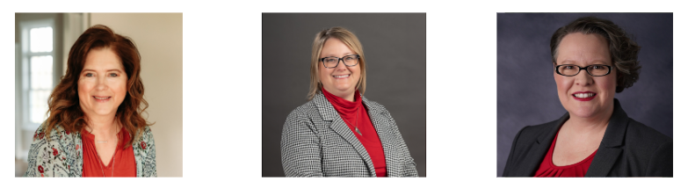
Collaboration with Indianhead Enterprises for connection and relationship building. FoodWIse team met staff, toured their facility, and are planning programming starting in August. This effort will enhance the life skills for adults with varying intellectual and developmental abilities.
A series of virtual strength training sessions (StrongBodies) for adults in the community, where participants engage in regular, progressive strength training and health education to improve their physical and mental health, and enhance social connectedness. Sandy led in May and connected with Margaret Murphy who presented a program on adaptive gardening.
Support to the Menomonie Farmers Market who celebrated their season opener and 25th Anniversary with a Menomonie Chamber ribbon cutting on May 21st.
Collaboration with Health Dunn Right to locally distribute paper copies of the updated Community Resource Guide.

Spotlight
Studies on teaching young children about fruits and vegetables consistently demonstrate that repeated exposure, positive experiences, and engaging activities, like gardening and cooking, are key to fostering healthy eating habits. Early introduction to a variety of fruits and vegetables, combined with education and positive reinforcement, can significantly impact children's preferences and consumption of these foods.
FoodWIse education incorporates the following key findings and messages (Part 2):
Curriculum-based approaches:
Integrating nutrition education into the curriculum can help children learn about the benefits of fruits and vegetables and their importance for health. Studies have shown that various interventions, including curriculum-based education, taste exposures, and garden-based programs, can lead to significant increases in children's consumption of fruits and vegetables.
Storytelling and character-based interventions:
Using characters like "Potter the Otter" or "Toasty" can make learning about healthy eating more engaging and memorable.
Human Development and Relationships
Luisa Gerasimo | Human Development and Relationships Educator
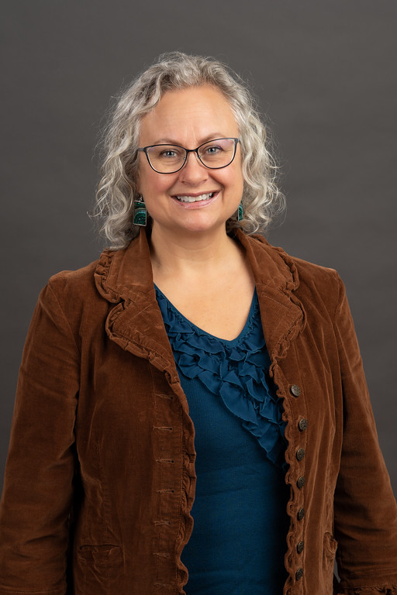
A co-parenting class (Parents Forever) for parents and caregivers experiencing separation, divorce or changes in the custody of their children, where they learned to prioritize the parent-child relationship and better communicate with their co-parent. This program is designed to increase child well-being and reduce parental conflict during family transitions. (In partnership with: Missy Bablick, Barron County)
A monthly topic-specific series (Resilient Co-Parenting) for parents and caregivers experiencing changes in the custody of their children. This series is designed to improve understanding of positive parenting practices that are useful during stress, while providing social connection for parents. (In collaboration: Hannah Zellmer, Adam Trunzo, Amanda Griswold, Beverly Doll, Heidi Ungrodt, Mary Campbell Wood, Missy Bablick, Pamela Wedig-Kirsch, Pattie Carroll, Renee Koenig, Todd Wenzel, Tracy Henegar)
Spotlight
Preschool Communication Screening at the Menomonie Public library: A Birth to Three staffer who was working with me on another project asked if I would like to participate. The Lion's Club offered free vision screenings, the Birth to Three professionals offered resources, and I helped families connect to the Just in Time Parenting Newsletter and upcoming parenting classes. The families who came to meet with us walked away with critical resources and information. The aim of this event was to help families better understand their children's needs.
Positive Youth Development
Zachary Rozmiarek | 4-H Program Educator

The June Clover Courier can be viewed HERE.
Preparing for both Outpost and Base Camp experiences at Kamp Kenwood and Lake Wissota State Park. Camp is both a leadership and learning opportunity for older youth and an opportunity for younger youth to make new friends, experience challenging growth, and explore their sparks. (In collaboration with: Rachel Hart-Brinson and Seth Harrmann)
A one-day camp counselor training where youth counselors practiced leading sessions and giving feedback to fellow counselors to prepare them to provide a quality camp experience. (Partnered with: Rachel Hart-Brinson and Seth Harrmann)
Value Added Programming
Co-Chairing the Chippewa Valley Suicide Prevention Workgroup, which covers suicide prevention efforts in Chippewa, Dunn, and Eau Claire Counties. The goal of this group is to collaborate on efforts to reduce deaths by suicide in the region. (Margo Dieck)
Navigator enrollment assistance provided to anyone in Wisconsin, where 97,013 consumers were assisted with health insurance questions or enrollment. Through this effort, our Navigators completed 4,041 qualified health plan enrollments through the federal Health Insurance Marketplace and assisted 5,615 consumers with Medicaid, resulting in widespread access to health care and improved health outcomes. (Adam Vanspankeren, Allison Espeseth, Elizabeth Rothe)
A coaching program for families and individuals, where participants learn how to create financial goals and gain money management skills. The goal of this program is to enable participants to prepare for and take charge of household financial situations that occur due to changes in income or unforeseen hardships. (Jeanne Walsh)
Area Extension Director
Kristen Bruder | Area Extension Director – Dunn, Chippewa, and Eau Claire Counties

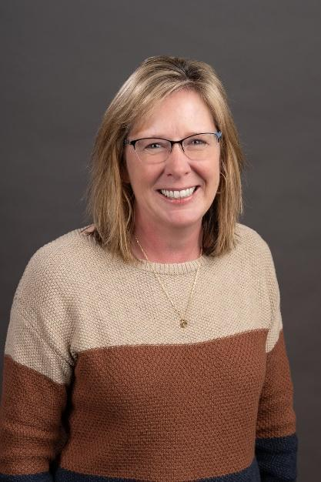
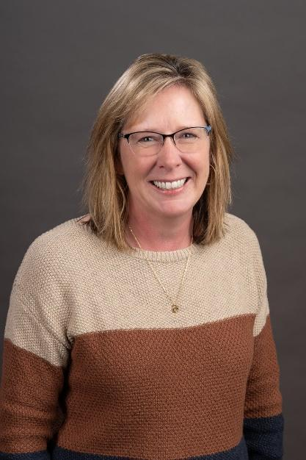
Please reach out with questions and ideas. The role of the AED is much like the department head in the county. Below is a brief overview of the role of AEDs: Extension fully invests in Area Extension Directors (AEDs) who oversee an area. These administrative positions are responsible for partnership management, staff development, financial management and program coordination.

Through the many interactions the AED has with county partners and local educators, the AED develops a solid understanding of the local needs and county priorities and helps to align Extension educational programs to ensure the programs address county needs. Educators also communicate local needs to their programmatic Institutes which collectively identify opportunities to address statewide needs.

Upcoming events
Event Calendar – Extension

Dunn County Extension in the News
Luisa Gerasimo:
Dunn County offers free online WeCOPE sessions for stress relief

